CAPTAINY

Project Documentation Template

Prepared by:

Sarah Abd Eldaym (Team Leader)

Hossam Adel

Shrouk Mamduh

Amira Emad

Track: Open Source.

ENG/ Noha Salah

Intake No. 42

24/7/2022

1. Introduction 1

1.1 Background(Problem)

1.2 Purpose

1.3 Previous work done(Competitors Analysis)………………………………………………………………

1.4 Customers' Analysis………………………………………………………………………………………….

1.5 Scope

1.6Stakeholders/Beneficiaries………………………………………………………………………………….

1.7 Business Model………………………………………………………………………………………………..

2. Requirements 6

*2.1 User/Functional Requirements*

2.1.1<List of Functional Requirements or Features>

2.2 Use Cases

2.2.1 Actors

2.2.2 List of Use Cases

*2.2.3 Use Case Diagrams…………………………………………………………………………………………………….*

2.3 Classes

2.3.1 <List of Classes >

2.4 Non-Functional Requirements

2.4.1 Performance Requirements(Availability, Security……etc.)

3. Objectives/List of Services(measurable) 10

4. Design Overview 12

4.1 System Architecture

4.2 Data Design(Entity Relationship Diagram)

5. Implementation 15

*5.1 Tools & Technologies*

*5.2 Hardware Requirements………………………………………………………………………………………………….*

*5.3 Steps of Installation.......................................................................................................................................*

6. User/Customer Testing 18

*6.1 Users/Customers Feedback……………………………………………………………………………………………*

*6.2 Improvements done................................................................................................................*

7. Recommendations(Future Work) 21

8. User Guide(See Attachment) 22

*8.1 Quick Start Guide*

*8.2 Main Scenarios………………………………………………………………………………………………………………*

*8.3 Troubleshooting...............................................................................................................................................*

1. **INTRODUCTION**

**1.1 BACKGROUND:**

Online fitness coaching has been rising in popularity due to people's tight schedules and busy lives but finding your perfect coach has always been a hassle. you don’t know where to look (they are scattered everywhere on the social media platforms), do they match my fitness goals? What about the prices? Can’t find honest reviews that are not managed by the coach? Well, that was from yesterday, because by using our application, finding your perfect coach is just a few clicks away from you.

**1.2 Purpose**

For Coaches

for coaches, it provides a new platform for them to market their services.

Gives them the flexibility that allows them to match it with their schedules and allows them to monitor their competitors’ prices so they can compete better in the market.

For user

the purpose of the app is to cover the gap between the clients and the coaches and provide a well trusted stable method where clients can be sure to get honest reviews and a platform where they don't have to search on all social media platforms for personal coaches

**1.3 Previous Work Done (Competitors Analysis)**

The idea has not yet been implemented in Egypt

But it is implemented outside Egypt in different forms Like:

-FitnessTrainer.com: 2- find your trainer

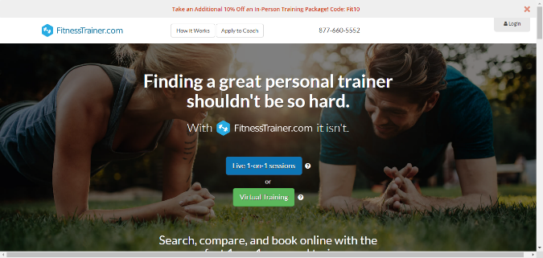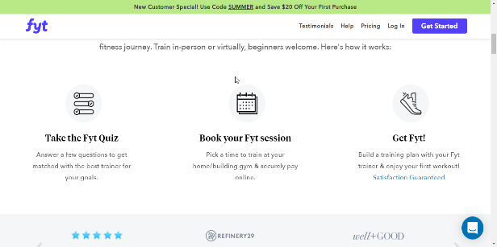

**1.4 Customers’ Analysis**

* **Geographic:**
* **Alexandria and Cairo**
* **Psychographic:**
* **Interest: New Sports**
* **Beliefs: quality of time** 
  1. **Scope**

The website addresses people in Alexandria, who are interested in sports. The website includes different coaches’ specialties.

There are three types of users which are coaches and Clients.

* **Clients**

The client can search for the perfect coach by (gender- rate – city- district)

The client can rate and comment on the coach’s profile based on the performance of the coach

* **Coaches**

The coach can decide his shift, fees, and How to communicate with the Client

* **Admin**

Can CRUD (Coaches – Cities – Districts – Admins – Feedback)

* 1. **stakeholders/Beneficiaries**
* Gyms Owners
* Coaches
* Clients

1.7 **Business Model**

Business-To-Consumer Models (B2C)

1. **REQUIREMENTS**

2.1 **User Functional Requirements.**

**2.1.1 Admin**

- The admin can log in using email & password or reset his password.

- The admin should have an admin panel where he can have some statistics about the business.

- Admin can view, create, update, and delete other admins depending on the business need.

- Admin can view, create, update, and delete Clients.

- Admin can view, create, update, and delete Coaches.

- Admin can view, create, update, and delete Specialties.

- Admin can view, create, update, and delete Countries,

Cities, and districts.

- Admin can view, create, update, and delete appointments.

- Admin can only view feedback.

- Admin can update the site setting.

**2.1.2 Coach**

**-** Coach can register using email & password.

- Coach can log in with his email & password and reset his password.

- Coach can update his profile.

- Coach can manage his appointments with the clients.

- Coach can manage his schedule to add or remove days and times.

**2.1.3** **User**

**-** Users can register using email & password.

- Users can log in with email & password and reset his password.

- Users can update their profiles.

- Users can search coaches by (City, district, specialty, and name)

- Users can filter coaches by gender.

- Users can sort coaches by rate & price.

- Users can view the coaching page to get more details about the coach (like schedule and reviews)

- Users can book an appointment from the coach's daily schedule table.

- Users can view other clients' reviews and create their own reviews.

- Users can view and manage their appointments with the coaches.

**2.2 Use Cases**

2.2.1 **Actors**

* User (Client)
* Admin
* Coach

‎

2.2.2 **List of Use Cases**

* **Register/Sign up**

Description:

This feature enables the Client to register for a new account.

Use Case Scenario:

1. Client enters:

·        Name

·        Email

·        Password

·        Confirm password

·        Mobile

·        Gender

·        Birth Date

1. System will save all this data in the database after validation
   * **Login**

Description:

This feature enables clients, admin, and coaches to log in to their created accounts by filling in email and password fields correctly.

Use Case Scenario for the client:

1. From the Home page user finds signup/login in the nav bar

2. User selects the login

3. User enters the email and password to login

4. User has the option to logout the website

* + **Edit Profile**

Description:

This feature enables users to edit their profile information

Use Case Scenario:

1. From the nav bar player can select view profile

2. From the profile page Client can edit the profile

Edit fields

* Name in English
* Email
* Mobile
* Date of birth
* Gender
* Image
* **View Home Page**

Description:

This feature enables users to view information about the Website.

Use Case Scenario:

Users can search for coaches using:

* name
* district
* country
* Specialty
* coach name

Users can view all available coaches and select one of them

Users can view a paragraph to know why to use “capital”

Users can view a HOW IT WORKS section for the program

* **View Coach search**

Description**:**

  This page will be shown after clicking the search button

all available coaches related to the search criteria will be displayed

Use Case Scenario:

Users can filter Coaches based on

* Rate
* Gender

 Users can sort Coaches based on

* Rate (From up to low)
* Fees (From up to low And from Low to Up)
* **Coach Page**

Description**:**

This page will be Shown After clicking the Book button, a page containing all necessary information will appear

Use Case Scenario:

Users can view

* Coach information
* Specialty
* Address
* Age
* Session
* Time slots

Users can view and choose the suitable session date to talk to the coach

* Reviews

Users can view Coach Reviews and rates from other clients

* Add Review and Comment

Users can add their own reviews and rate after finishing the session with the coach

**2.2.3 Use Case Diagram**

2.3 **Classes**

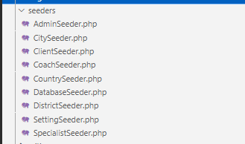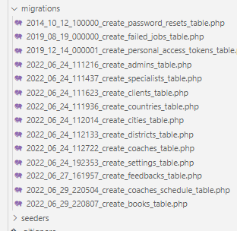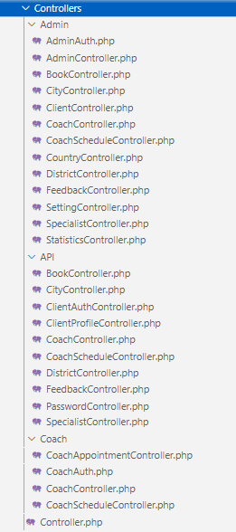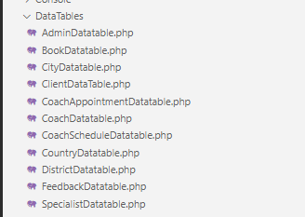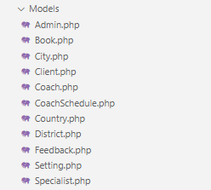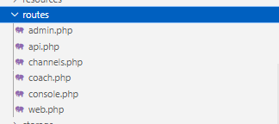

**2.4 Non-Functional Requirements**

* Security:

The Online Coaching Web App must be secured with proper usernames and passwords.

accuracy, completeness, and consistency of data.

Data Authentication for the Client before making any request

* Performance:

The user's query will be processed once the user enters the required information in 20 seconds, which is a reasonable amount of time compared to other systems with the same scope on the market.

* Environmental:

The Online Coaching Web App must be working in the latest operating system environments like windows 8, windows 10, windows 11, and Linux.

Data Integrity

All the data in the Online Coaching Web App must be accurate and reliable.

* Usability:

The Online Coaching Web App must have a good-looking user-friendly interface and a Low probability of failure

* Availability:

The Online Coaching Web App must be available 24 hours a day with no bandwidth issues.

3. **OBJECTIVES/LIST OF SERVICES**

 Less wastage of time:

Due to Online Coaching App, you can make sure that the whole working day is scheduled in such a way that you make the most of your time and that there is no time during the day that you will be idle or wasting time. This is a very good system for the time management of both coaches and Clients

To allocate only the required amount of time:

Each appointment can run for different amounts of time. The Online Coaching App aims to help the Client and the Coach allocate only the amount of time that will be needed for that appointment so that the individuals will be able to know exactly how much time they have for the meeting and be able to schedule something else that can be productive in the remaining amount of time.

 Improves patient satisfaction

Client experience is of paramount importance. No Client would like an experience that is not smooth. An online Coach appointment system enhances patient Client. Patients no longer have to be worried about the time wasted in searching a good coach. They can Review and Rate Coaches.

**4.2** **DATA DESIGN (ENTITY RELATIONSHIP DIAGRAM)**

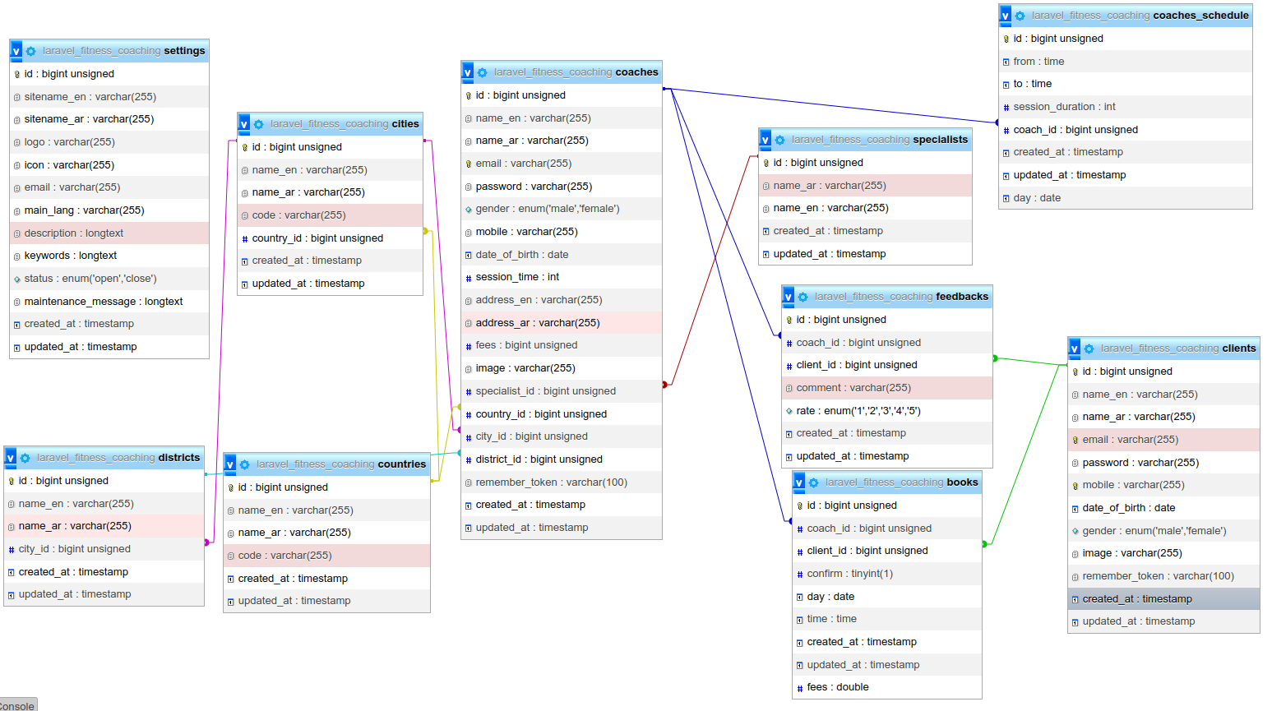

5. **IMPLEMENTATION**

* 1. Tools & Technologies
* Laravel
* Reacts
* MySQL
* Bootstrap
* HTML & CSS
  1. Hardware Requirements

Operating System window ^8

Laravel / framework ^8.0.1

5.3 Steps of Installation

* 1. Download the zipped file and unzip it or clone it
* git clone https://github.com/SarahAbdeldaym/Online_Coaching_App.git
  1. cd inside the project
* cd Online_Coaching_App
  1. Run this command to download composer packages
* composer update
  1. Run this command to update composer packages
* composer install
  1. Create a copy of your .env file
* cp .env.example .env
  1. Generate an app encryption key
* php artisan key:generate
  1. Create an empty database for our application in your DBMS

In the .env file, add database information to allow Laravel to connect to the database

* 1. Migrate the database
* php artisan migrate
  1. Seed the database
* php artisan db:seed

10. Generate Storage folder in your public directory to store uploaded files or images

* php artisan storage:link

11. Open up the server

* php artisan serve

**6. USERS/CUSTOMERS FEEDBACK**

**7. Recommendations(Future Work)**

* Feedback Crud by Admin
* Chat between Client and Coach
* Report Coach

**8. USER GUIDE (SEE ATTACHMENT)**

* 1. **Quick Start Guide**

User will Start from The Home Page. Click on Login Button and Login if Registered.

If not, user will click login.

* 1. **Main Scenarios**

1. 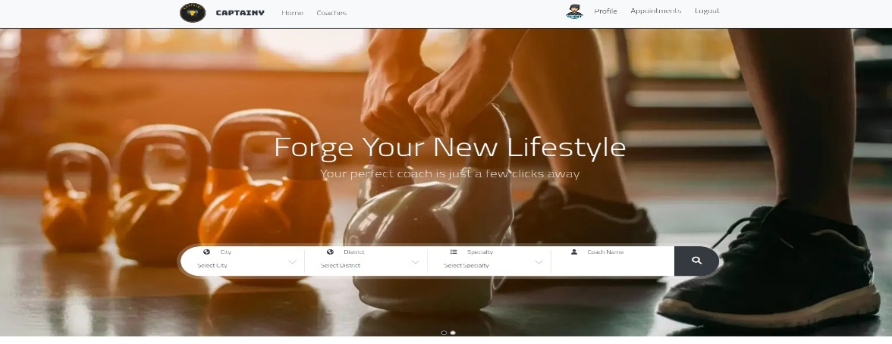Landing Home Page.
2. 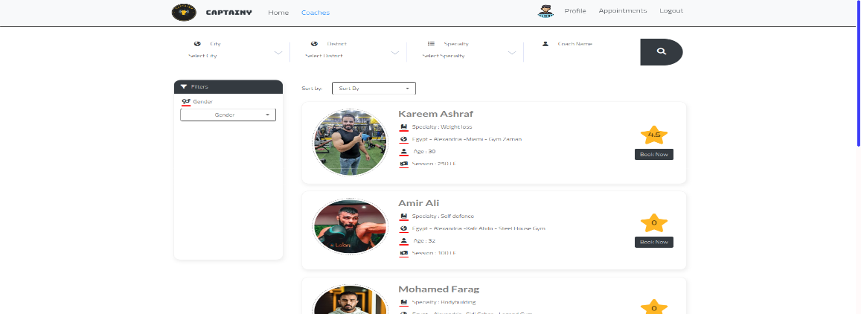After Searching
3. After Choosing a Specific Coach

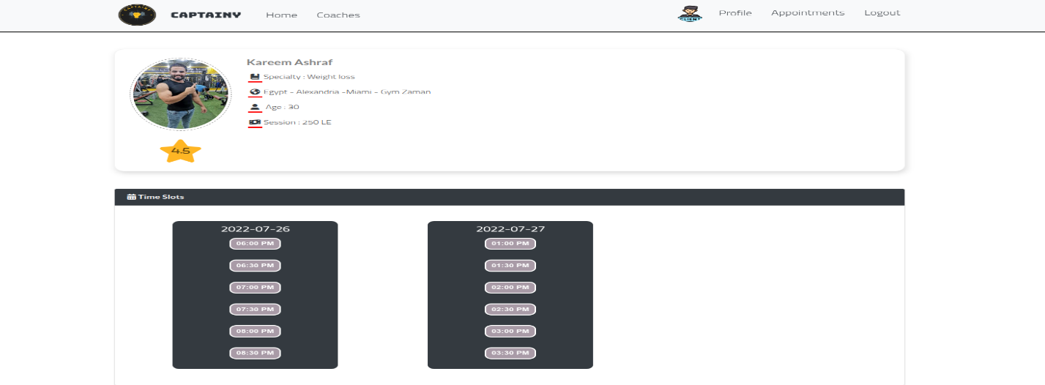

1. After Booking an Appointment

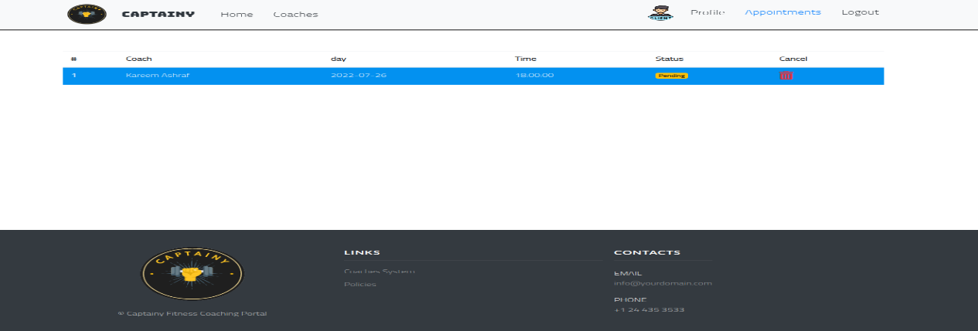

1. Reviewing Coach After Finishing the Session

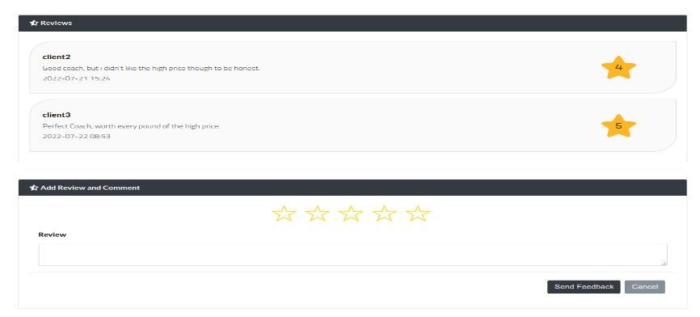

1. Graphical user interface, website

   Description automatically generatedEdit Profile